Gateway Chemistry A (9-1)  C3 Chemical Reactions  Science Department | 
OCR ExamBuilder process constraints mean you may  see slight differences between this paper and the  original.  Candidates answer on the Question Paper.  A calculator may be used in this paper.  OCR supplied materials:  Additional resources may be supplied with this paper.  Other materials required:  • Pencil  • Ruler (cm/mm) | Duration: Not set

INSTRUCTIONS TO CANDIDATES
• Write your name, centre number and candidate number in the boxes above. Please write clearly and in capital letters.
• Use black ink. HB pencil may be used for graphs and diagrams only.
• Answer all the questions.
• Read each question carefully. Make sure you know what you have to do before starting your answer.
• Where space is provided below the question, please write your answer there.
• You may use additional paper, or a specific Answer sheet if one is provided, but you must clearly show your candidate number, centre number and question number(s).

INFORMATION FOR CANDIDATES
• The quality of written communication is assessed in questions marked with a pencil or an asterisk.
• The number of marks is given in brackets [ ] at the end of each question or part question.
• The total number of marks for this paper is 63.
Answer all the questions.

1. | Space probes have been sent to Mars to analyse the soil.  One compound analysed has the formula Ca(ClO₄)₂.  Calculate the molar mass of Ca(ClO₄)₂.  The relative atomic mass, A_{r}, of O = 16, of Cl = 35.5 and of Ca = 40.  molar mass ............................. g/mol  [1]

2. | There are many compounds that contain carbon and hydrogen only.  Pentane has the formula CH₃(CH₂)3CH₃.  Calculate the molar mass of pentane.  The relative atomic mass, A_{r} , of H = 1 and of C = 12.  molar mass = ..................... g / mol  [1]

3. | Phil is a research chemist.  He investigates a new pharmaceutical drug.  Phil extracts the drug from the leaves of a plant.  He purifies the drug and then checks to see if he has made a pure sample.  Phil uses two tests to check the purity of the drug  - melting point  - thin layer chromatography.  Look at the results of his tests.  Melting point  Thin layer chromatogram of sample of the drug obtained from the plant.  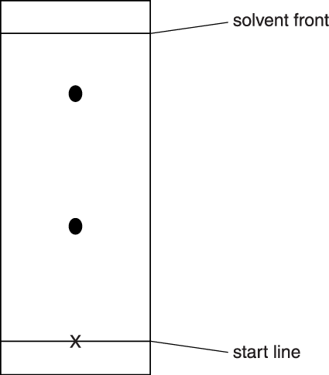  Write about how a sample of the drug is obtained from the leaves of a plant.  What do the results of his tests show about the purity of the sample?  The quality of written communication will be assessed in your answer to this question.  [6]
  Substance | Melting point in °C
  pure drug | 175
  sample of the drug obtained from plant | 171 – 173

4. | Crude oil is separated into many fractions by fractional distillation.  The diagram shows a fractionating column.  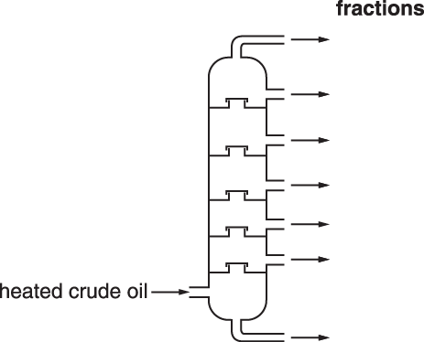  Look at the table. It shows the boiling point range for some of the fractions.  Write down the name of the fraction which ‘exits’ from the bottom of the fractionating column.  [1]
  Fraction | Boiling point range in °C
  bitumen | above 350
  heating oil | 240 to 350
  paraffin | 120 to 240
  petrol | 20 to 70
  LPG | −160 to 20

5. | Sodium chloride is an ionic compound.  Carbon dioxide is a covalent compound.  Look at the table.  - Complete the table.  [2]  - Carbon dioxide has a low melting point.  Explain why, using ideas about forces.  [1]
   | Sodium chloride | Carbon dioxide
  Formula | NaCl | CO₂
  Type of particles present | ions | .....................
  Melting point | ..................... | low

6. | Rosa tests some compounds to find out if they conduct electricity.  Which row in the table shows the correct results for each compound?  Your answer   [1]
   | Solid ionic compound | Ionic compound dissolved in water | Molten ionic compound
  A | conducts | does not conduct | conducts
  B | conducts | conducts | conducts
  C | conducts | conducts | does not conduct
  D | does not conduct | conducts | conducts

7. | Look at the diagrams.  They show the structures of two compounds.  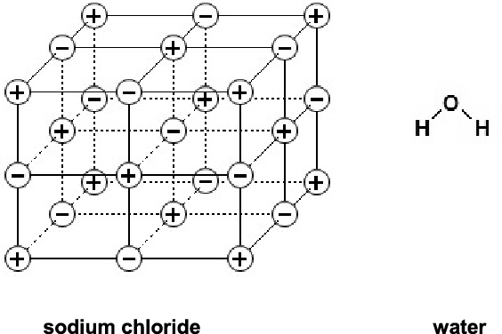  Magnesium oxide has a similar structure to sodium chloride.  Draw ‘dot and cross’ diagrams to show the ionic bonding in magnesium oxide.  You should include the charges on the ions.  The electronic structure of magnesium is 2.8.2.  The electronic structure of oxygen is 2.6.  [3]

8. | This question is about diamond and graphite.  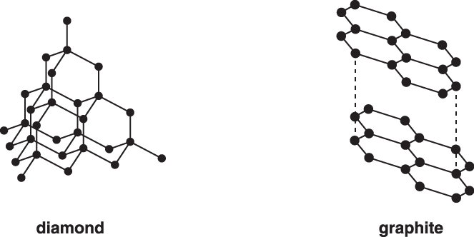  Diamond and graphite are made of the same element.  Which element?  [1]

9. | The diagrams show the structures of two forms of carbon.  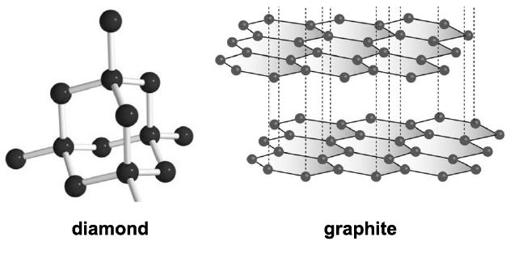  Graphite is a good conductor of electricity.  Diamond does not conduct electricity.  Use ideas about structure and bonding in diamond and graphite to explain these observations.  [3]

10. | Diamond and graphite have different properties and different uses.  Look at the table.  It shows some information about the properties of diamond and graphite.  Diamond is used to make cutting tools.  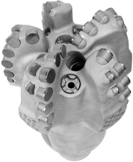  The picture shows a drill bit with diamonds on its end.  This drill is used to cut through rock.  Explain why diamond is used to make cutting tools.  Use the table to help you.  [2]
  Property | Diamond | Graphite
  State at room temperature | solid | solid
  Appearance at room temperature | transparent | black
  Melting point | very high | very high
  Hardness | very hard | soft
  Electrical conductivity | does not conduct | good conductor

11. | Describe, using a labelled diagram, what is meant by metallic bonding.  [2]

12. | One property of metals is that they often have high melting points.  Write about other properties of metals.  [2]

13. | One scientist who helped to develop the Periodic Table was called Mendeleev.  Write about how Mendeleev helped in the development of the Periodic Table.  [2]

14(a). | The table shows the electronic structures of the atoms of some elements.  Write down the symbols for two elements in the same group of the periodic table.  Choose from the table above.  .............. and ..............  [1]
  Element | Symbol | Electronic structure
  helium | He | 2
  oxygen | O | 2.6
  neon | Ne | 2.8
  magnesium | Mg | 2.8.2
  chlorine | Cl | 2.8.7
  calcium | Ca | 2.8.8.2

(b). | Write down the symbols for two elements in the same period of the periodic table.  Choose from the table above.  .............. and ..............  [1]

15. | Ammonium sulfate is a salt.  It is manufactured using the reaction between the alkali ammonia and sulfuric acid.  What type of reaction is this?  [1]

16(a). | Look at the energy profile for a reaction.  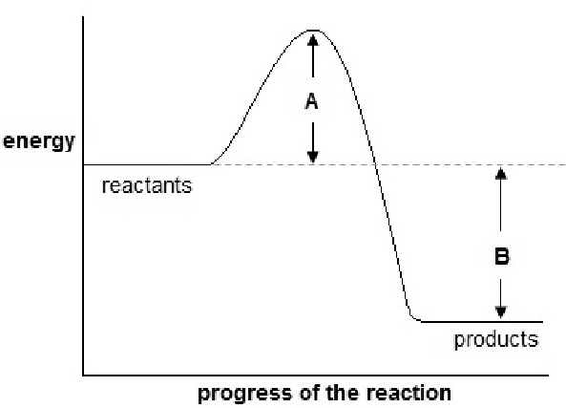  What can you deduce about this reaction?  Include the quantities A and B and a full explanation.  [4]

(b). | Look at the equation.  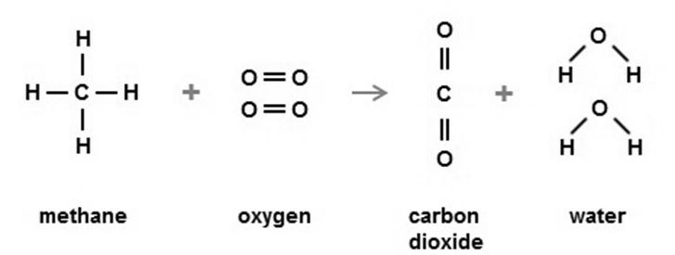  The table shows the bond energies of the bonds involved.  - What type of energy change happens when bonds are broken and when bonds are made?  Bonds broken ...........................................................  - Calculate the energy change for this reaction.
  Bond | Bond energy (kJ/mol)
  C-H | 435
  O=O | 498
  C=O | 805
  O-H | 464
  Bonds made ........................................................... | [2]
  Energy change = ........................................................... kJ/mol | [3]

17. | Copper is also made by the electrolysis of copper sulfate solution.  Look at the diagram of the apparatus used in this electrolysis.  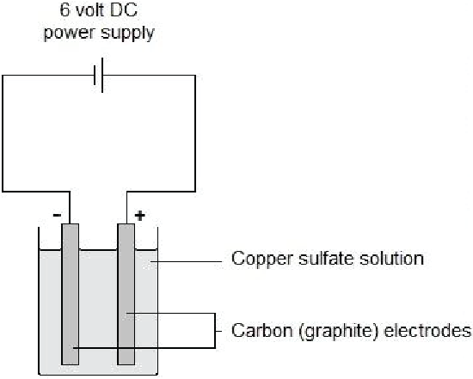  Describe what you would see at each of the electrodes.  [2]
  At the anode:
  At the cathode:

18. | Meena electrolyses copper sulfate using copper electrodes.  Look at the diagram. It shows the apparatus she uses.  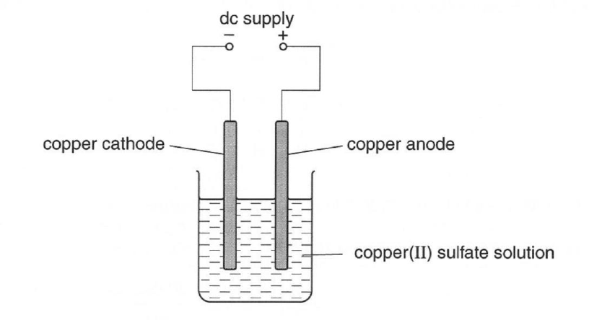  She investigates the change in mass at each electrode before and after the electrolysis.  Look at Meena's method.  Meena finds that  - the cathode gains mass  - the anode loses mass.  Explain these observations in terms of the reactions at each electrode.  [2]
  1. Using a balance, measure the mass of the copper cathode and copper anode.
  2. Set up the apparatus and run the electrolysis for 30 seconds.
  3. Remove the copper cathode and the copper anode and immediately place them on the balance and measure their masses again.

19. | Molten aluminium oxide contains Al³⁺ and O²⁻ ions.  The electrolysis of molten aluminium oxide makes aluminium and oxygen.  - Write the balanced symbol equation for the electrode reaction that happens at the cathode.  Use the symbol e⁻ to represent an electron.  [1]  - Solid aluminium oxide cannot be electrolysed.  Explain why.  [1]

20. | Molten (liquid) salts can be electrolysed.  Sanjay does an electrolysis experiment using potassium bromide.  Solid potassium bromide cannot be electrolysed.  Molten (liquid) potassium bromide can be electrolysed. It makes two products.  - Write down the names of the two products made during this electrolysis.  [2]  - Explain why molten (liquid) potassium bromide can be electrolysed.  [1]

21. | Ann neutralises nitric acid with potassium hydroxide solution.  Which of these shows the ionic equation for neutralisation?  Your answer  [1]

22(a). | Zinc nitrate can be made by reacting zinc oxide with nitric acid, HNO₃.  Paul suggests this method for preparing zinc nitrate.  Paul's method will not make a pure dry sample of zinc nitrate.  What improvements should Paul make to the method to make sure that:  - the reaction is complete  - the zinc nitrate can be separated from the nitric acid and the zinc oxide?  Explain your answer.  [4]
  1. Measure 50cm³ of dilute nitric acid into a beaker.
  2. Add one spatulaful of zinc oxide.
  3. Heat the mixture until crystals of zinc nitrate are made.

(b). | Describe why this reaction is a neutralisation reaction.  [2]

23(a). | An acid reacts with a base to make a salt and water.  acid + base → salt + water  Look at the table. It shows some acids, bases and the salts made from them.  Complete the table.  [3]
  Acid | Base | Salt
  sulfuric acid | copper oxide | copper sulfate
  nitric acid | sodium carbonate | ............................................
  ............................................ | zinc oxide | zinc chloride
  sulfuric acid | ............................................ | magnesium sulfate

(b). | Hydrochloric acid, HCl, reacts with calcium carbonate, CaCO₃.  Calcium chloride, CaCl₂, carbon dioxide and water are made.  Write a balanced symbol equation for this reaction.  [2]

24(a). | In this reaction the K⁺(aq) and the NO₃?(aq) are called spectator ions.  What is meant by a spectator ion?  [1]

(b). | Sam researches different ways of making insoluble salts such as lead iodide.  In one reaction she adds potassium iodide solution to lead nitrate solution.  Potassium iodide solution contains K⁺(aq) and I?(aq).  Lead nitrate solution contains Pb²⁺(aq) and NO₃?(aq).  Look at the balanced ionic equation for the precipitation reaction.  Pb²⁺(aq) + 2I?(aq) ? PbI₂(s)  Explain why this precipitation reaction is extremely fast.  [1]

END OF QUESTION PAPER

Mark scheme
Question |  |  | Answer/Indicative content | Marks | Guidance
1 |  |  | 239 (1) | 1 | ?Examiner's Comments??  Many candidates could calculate the molar mass as 239 g/mol.
 |  |  | Total | 1
2 |  |  | 72 (1) | 1 | unit not needed  ignore any unit given  Examiner's Comments  Many candidates could calculate the molar mass of pentane as 72 g/mol.
 |  |  | Total | 1
3 |  |  | Level 3  Describes two stages of extracting drug from plant material  AND  Explains why the drug is impure using both melting point and chromatography data.  Quality of communication does not impede communication of science at this level.  (5-6 marks)  Level 2  Answer describes one stage of extracting drug from plant material AND explains why the drug is impure using either melting point or chromatography data  OR  Answer describes two stages of extracting drug from plant material.  OR  Explains why the drug is impure using both melting point and chromatography data.  Quality of written communication partly impedes communication of the science at this level.  (3 – 4 marks)  Level 1  Describes one stage of extracting drug from plant material  OR  Explains why the drug is impure using either melting point or chromatography data.  Quality of communication impedes communication of the science at this level.  (1 – 2 marks)  Level 0  Insufficient or irrelevant science. Answer not worthy of credit.  (0 marks) | 6 | This question is targeted at grades up to C  Indicative scientific points for extraction may include:  - Crushing (plant material)  - Boiling (with a solvent)  - Dissolving (with a solvent) / solvent extraction  - Chromatography  - Crystallisation  - Evaporation  - Filtration  Indicative scientific points for analysis may include:  - Drug is impure  - Chromatography shows that there are (at least) two substances (so not pure)  - Melting point is below that of the pure sample so not pure  - Melting point is a range so not pure  Use the L1, L2, L3 annotations in Scoris, do not use ticks  Examiner's Comments  This question was about pharmaceutical drugs.  The six mark question was a common question with the higher tier examination paper and candidates found it very challenging. Most candidates were not able to use the melting point or chromatography data to explain why the sample was impure. Candidates did not appreciate that the two spots on the chromatography paper indicated two compounds. In terms of describing how the drug is extracted from a plant most candidates gave the name of a process but were not able to give an accurate description of what happened with the process. A significant proportion of the candidates made no attempt to answer the question.
 |  |  | Total | 6
4 |  |  | bitumen (1) | 1 | allow phonetic spelling  Examiner's Comments  Many candidates could interpret the data in the table.
 |  |  | Total | 1
5 |  | i | molecules (1)  high (1) | 2 | 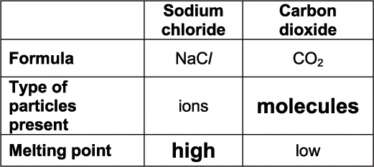  Examiner's Comments  Many candidates appreciated that the melting point of sodium chloride was high but could not name the particles present in carbon dioxide. Many candidates wrote atoms, ions or electrons and only a very small proportion of candidates gave the correct particle, a molecule.
 |  | ii | weak forces between molecules / weak intermolecular forces (1) | 1 | allow weak forces between particles, but not weak forces between ions or between atoms  allow weak intermolecular bonds / weak bonds between molecules  not weak intermolecular forces between atoms / weak covalent bonds  weak forces and weak bonds on their own are not sufficient  Examiner's Comments  Many candidates appreciated that the low melting point of carbon dioxide was due to a weak force but a significant proportion had this as a weak force between atoms rather than between molecules. The best answers referred to weak intermolecular forces.
 |  |  | Total | 3
6 |  |  | D | 1
 |  |  | Total | 1
7 |  |  | 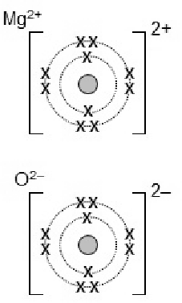  electronic structure of magnesium ion (1)  electronic structure of oxide ion (1)  charges correct on both ions (1) | 3
 |  |  | Total | 3
8 |  |  | carbon (1) | 1 | allow C  Examiner's Comments  This part was found to be challenging.
 |  |  | Total | 1
9 |  |  | graphite – has a layered structure (1)  electrons can move / electrons between layers or delocalised (1)  diamond – no free electrons or ions (1) | 3
 |  |  | Total | 3
10 |  |  | any two from:  (diamond) has a high melting point (1)  (diamond) is very hard (1) | 2 | ignore other properties from the table  allow (diamond) is a good thermal conductor (1)  Examiner's Comments  Most candidates correctly interpreted the data in the table and explained that diamond is used to make cutting tools because it is hard and has a high melting point.
 |  |  | Total | 2
11 |  |  | idea of an attraction or bond(ing) between positive ions and electrons (1)  (closely packed) metal ions and delocalised electrons (1) | 2 | do not allow intermolecular forces / covalent bonding / ionic bonding / metal molecules = 0 for the question  allow positive atoms, cations, positive ions instead of metal ions and free electrons instead of delocalised electrons.  allow has electrons free to move instead of delocalised or free electrons / sea of electrons instead of delocalised electrons  allow mark could be found on a labelled diagram  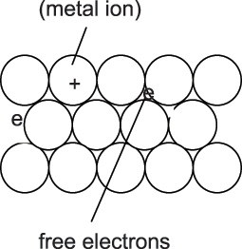  Examiner's Comments  Most candidates could not describe metallic bonding and a significant proportion of candidates left this question blank. The best answers described the attraction between the delocalised electrons and positive ions however most candidates did not even appreciate that a metal has positive ions. Candidates often drew diagrams that were not labelled and did not show the positive ions in a closed packed arrangement. A small proportion of candidates tried to draw ‘dot and cross’ diagrams. Other candidates referred to ionic, covalent and intermolecular forces.
 |  |  | Total | 2
12 |  |  | any two from:  high boiling point (1)  (good) thermal conductor (1)  (good) electrical conductor (1)  high density (1)  malleable / flexible (1)  ductile (1)  lustrous (1)  hard (1)  high tensile strength (1)  sonorous (1)  have basic oxides (1)  form positive ions (1)  form ionic compounds (1) | 2 | ignore just a good conductor  ignore just dense  allow shiny  allow strong  allow often react with acids to give hydrogen  Examiner's Comments  Not well answered. A lot of the candidates talked about metallic structure without mentioning any property, many others gave uses for metals.
 |  |  | Total | 2
13 |  |  | any two from:  arranged elements in order of (relative) atomic mass (1)  left gaps in his table (for elements not yet discovered) (1)  predicted properties of elements (1)  arranged elements in periods (1)  arranged elements in groups (1)  realised that there was a periodic behaviour in the properties of the elements (1) | 2 | ignore reference to atomic number  ignore reference to mass number  allow predicted properties of ‘missing’ elements for two marks  allow arranged elements together with similar chemical properties  Examiner's Comments  This question was about chlorine and fluorine.  Many candidates gave good answers about the Periodic table in terms of atomic number and outer shell electrons but did not realise that these were not discovered until much later than Mendeleev’s Periodic Table. The best answers referred to grouping according to chemical properties and the gaps in the table that Mendeleev left for elements still to be discovered. A significant proportion of the candidates confused Mendeleev’s work with that of Newlands.
 |  |  | Total | 2
14 | a |  | Mg and Ca / He and Ne(1) | 1 | both needed  allow MG and CA / HE and NE  allow magnesium and calcium / helium and neon answer must be in table  Examiner's Comments  Many correct answers except for a few candidates who mixed up “group” and “period”.
 | b |  | O and Ne / Mg and Cl (1) | 1 | both needed  allow NE / MG and CL / Cl₂  allow oxygen / O₂ and neon / magnesium and chlorine answer must be in table  Examiner's Comments  Many correct answers except for a few candidates who mixed up “group” and “period”.
 |  |  | Total | 2
15 |  |  | Neutralisation (1) | 1
 |  |  | Total | 1
16 | a |  | any four from:  reaction is exothermic (1)  as reactants have more energy than products (1)  A is the activation energy (1)  activation energy is the amount of energy supplied to get the reaction started (1)  B is the energy change for the reaction (1)  the value of B is negative (1) | 4
 | b | i | bonds broken – endothermic (1)  bonds made – exothermic (1) | 2 | both required
 |  | ii | energy needed to break bonds = 2736 (kJ) (1)  energy released when new bonds form = 3466 (kJ) (1)  energy change for a reaction = 730 (kJ) given out / − 730 (kJ) (1) | 3 | Correct answer scores 3 if no working is shown
 |  |  | Total | 9
17 |  |  | Anode: bubbles / effervescence (1)  Cathode: Brown / salmon pink deposit / layer / coating (1) | 2 | Both correct descriptions but at wrong electrodes
 |  |  | Total | 2
18 |  |  | copper is deposited at the cathode (1)  copper anode dissolves / copper ions produced at anode (1) | 2 | ALLOW higher level answers in terms of half equations  e.g. at cathode Cu²⁺ + 2e⁻ → Cu (1)  e.g. at anode Cu → Cu²⁺ + 2e⁻ / Cu − 2e⁻ → Cu²⁺ (1)
 |  |  | Total | 2
19 |  | i |  | 1 | ALLOW any correct multiple  DO NOT ALLOW & or and instead of +
 |  | ii | Ions cannot move (1) | 1 | IGNORE electrons cannot move
 |  |  | Total | 2
20 |  | i | potassium (1) | 2 | allow K (1)
 |  | i | bromine (1) |  | allow Br₂ (1)  do not allow bromide  Examiner's Comments  The products were usually correctly identified as potassium and bromine. Bromide was a common error.
 |  | ii | ions can move / ions go to electrodes (1) | 1 | allow ions move to anode / ions move to cathode (1)  do not allow electrons can move  Examiner's Comments  A very common misconception was that molten potassium bromide can be electrolysed because the electrons can move.
 |  |  | Total | 3
21 |  |  | B | 1
 |  |  | Total | 1
22 | a |  | Any four from:  idea that an excess of zinc oxide must be added (1)  so reaction is complete / all nitric acid is reacted (1)  filter off excess zinc oxide (1)  evaporate off some of the water (1)  allow to crystallise (1) | 4
 | b |  | reaction between nitric acid (HNO₃), an acid and zinc oxide (ZnO), a base (1)  to make zinc nitrate (Zn(NO₃)₂, a salt and water (only) (1) | 2 | Only award marks if reactions and products are named in the answer  ALLOW the use of just chemical formulae
 |  |  | Total | 6
23 | a |  | 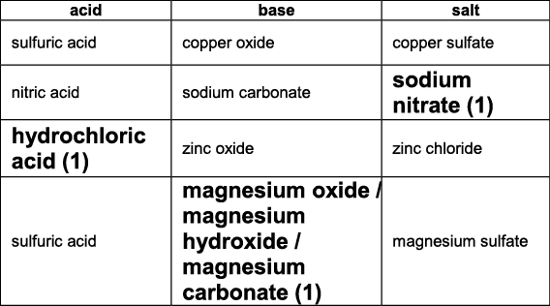 | 3 | allow correct formulae i.e.  NaNO₃ (1)  HCl (1)  MgO / Mg(OH)₂ / MgCO₃ (1)  Examiner's Comments  This question was about fertilisers.  Many candidates were awarded the marks for sodium nitrate and magnesium oxide (or carbonate). Hydrochloric acid was less well known, with chloric acid being a common response.
 | b |  | CaCO₃ + 2HCl ? CaCl₂ + CO₂ + H₂O  formulae correct (1)  balancing (1) | 2 | balancing mark is dependent on correct formulae  but  allow one mark for balanced equation with minor errors of subscripts, superscripts, etc eg  CACO₃ + 2HCl ? CaCl² + CO₂ + H2O  not and or & for +  allow = instead of ?  allow correct multiples eg  2CaCO₃ + 4HCl ? 2CaCl₂ + 2CO₂ + 2H₂O  Examiner's Comments  Candidates were able to balance the symbol equation, given the formulae. They found balancing the ionic equation.
 |  |  | Total | 5
24 | a |  | idea of ion that is in the solution at start and at the end of the reaction (1) | 1 | allow an ion present that takes no part in the reaction / ion that does not react / they do not contribute towards the reaction  ignore they do not change state during the reaction  ?Examiner's Comments??  Candidates often mentioned that spectator ions do not take part in a reaction.
 | b |  | collision frequency (between ions) is high (1) | 1 | allow large number of collisions (between ions) every second / lots of collisions (between ions) per unit time / high chance of collision (between ions) / highly likelihood of collisions (between ions)  not collision frequency between atoms or molecules is high  allow collision frequency between Pb²⁺ and I? is high  allow positive and negative ions attract / oppositely charged ions attract  allow has a low activation energy  ignore ions cancel out  Examiner's Comments  Most candidates did not appreciate that the collision frequency of ions must be very high if the reaction is fast. Many candidates stated that the collision frequency would increase but this was not sufficient to be awarded a mark.
 |  |  | Total | 2

